EV Market Performance & Insights Platform
Final Project Report
Submitted By: Siddharth Raghuwanshi
Date: 1 November 2026

1. INTRODUCTION
1.1 Project Overview
The "EV Market Performance & Insights Platform" is a comprehensive, full-stack Business Intelligence web application. It is built using a Python (Flask) backend and integrates interactive Tableau visualizations. The platform serves as a centralized portal that transforms complex, fragmented Electric Vehicle datasets into interactive dashboards and a guided data narrative.
1.2 Purpose
The purpose of this project is to bridge the gap between raw data and business strategy. By replacing outdated static reports with a self-serve web portal, non-technical stakeholders (such as executives and analysts) can dynamically filter market data, track Year-over-Year growth, and understand historical adoption trends in real-time without needing to write any code.

2. IDEATION PHASE
2.1 Problem Statement
Business stakeholders are currently overwhelmed by massive amounts of raw EV market data trapped in static PDFs and spreadsheets. Extracting actionable insights requires technical skills, forcing executives to wait days for a data team to run queries. This bottleneck severely slows down critical strategic decision-making.
2.2 Empathy Map Canvas
Target Persona: Emily Johnson, Strategic Analyst
- Says: "I need real-time data, not last month's report."
- Thinks: "Data requests take too long. I want visual data over complex sheets."
- Does: Manually searches CSVs, pastes screenshots into PowerPoint.
- Feels: Frustrated by delays, overwhelmed by fragmented data.
2.3 Brainstorming
- Rejected Ideas: Static PDF reports and standard Excel pivot tables (lacked interactivity).
- Selected Solution: A Flask Web App embedding Tableau Dashboards, offering maximum interactivity, professional UI, and a guided Story feature.

3. REQUIREMENT ANALYSIS
3.1 Customer Journey Map
- Discovery: User lands on the responsive Flask homepage (Relieved).
- Exploration: User interacts with Tableau filters and navigates the Story (Engaged).
- Decision: User extracts insights for leadership (Confident & Decisive).
3.2 Solution Requirement
- Functional: Dynamic filtering by region/year, KPI aggregation, interactive Tableau Story, responsive navigation.
- Non-Functional: Page load under 3 seconds, mobile-responsive UI (Bootstrap), high availability.
3.3 Data Flow Diagram & Tech Stack
- Data Source: EV Market CSV dataset.
- Processing: Python (Pandas) for cleaning nulls and duplicates.
- Visualization: Tableau Public (hosting 8 interactive charts).
- Integration: Tableau JavaScript API embedding the views into the HTML/Jinja2 templates.
- Frontend: HTML5, CSS3, Bootstrap 5, JavaScript.
- Backend: Python (Flask).

4. PROJECT DESIGN
4.1 Problem Solution Fit
- The Gap: Static data vs. Dynamic business needs.
- The Fit: The Flask app eliminates the middleman by providing a self-serve portal. It offers instant access to interactive charts and historical context via a Tableau Story, all within one unified URL.
4.2 Proposed Solution
The platform provides an 8-visualization interactive dashboard (KPI Cards, Bar Charts, Pie Charts, Heatmaps, Maps, Scatter Plots). It includes a guided Tableau Story that walks users through the chronological evolution of EV adoption, ensuring that complex data is easily digestible.
4.3 Solution Architecture
The architecture follows a modern web flow:
CSV Data -> Pandas (Data Prep) -> Tableau Public -> Flask HTML Template -> User Browser.
The Flask server handles routing via app.py, serves static assets, and uses the Tableau JS API to render the interactive charts on the client side.

5. PROJECT PLANNING & SCHEDULING
5.1 Project Planning
The project was executed solo using Agile methodology across two 7-day sprints:
- Sprint 1 (12 Story Points): Flask setup, Bootstrap UI, Dashboard creation & embedding.
- Sprint 2 (10 Story Points): Data Story creation, advanced filtering, final UI polishing.
- Total Effort: 22 Story Points. Final Release Date: 1 November 2026.

6. FUNCTIONAL AND PERFORMANCE TESTING
6.1 Performance Testing
- Data Preprocessing: 1,045 cleaned rows loaded successfully. 14 duplicates removed, missing values handled via dropna().
- Filter Efficiency: Tableau extracts allow cross-filtering in under 1 second.
- App Performance: Flask serves the page and initiates Tableau rendering in 2-3 seconds. All static assets return HTTP 200 OK.
- Implementation Rate: 100% of proposed features were successfully implemented and demonstrated.

7. RESULTS
7.1 Output Screenshots
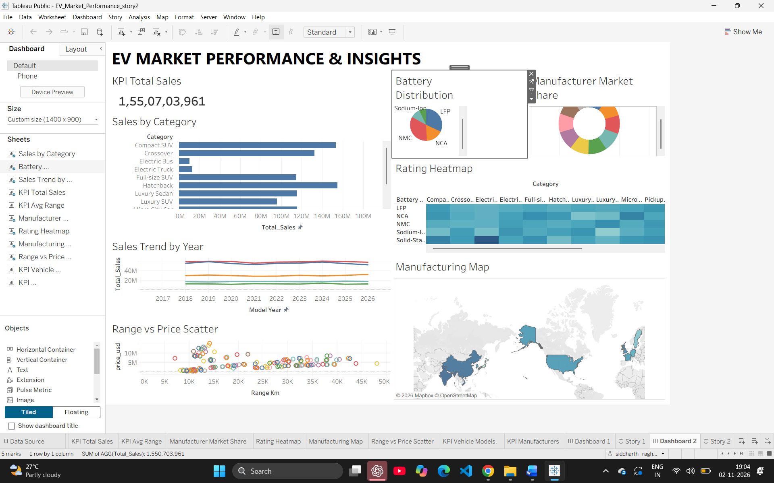Key Insights Uncovered:
- Category Dominance: Compact SUVs significantly outpace other segments in total sales volume.
- Battery Tech: LFP and NMC batteries currently hold the majority market share.
- Growth Trajectory: A consistent, uninterrupted upward sales trend from 2017 through 2026.
- Geographic Hubs: Manufacturing is highly concentrated in North America, Europe, and parts of Asia.
- Correlation: A strong positive correlation exists between vehicle range and price.
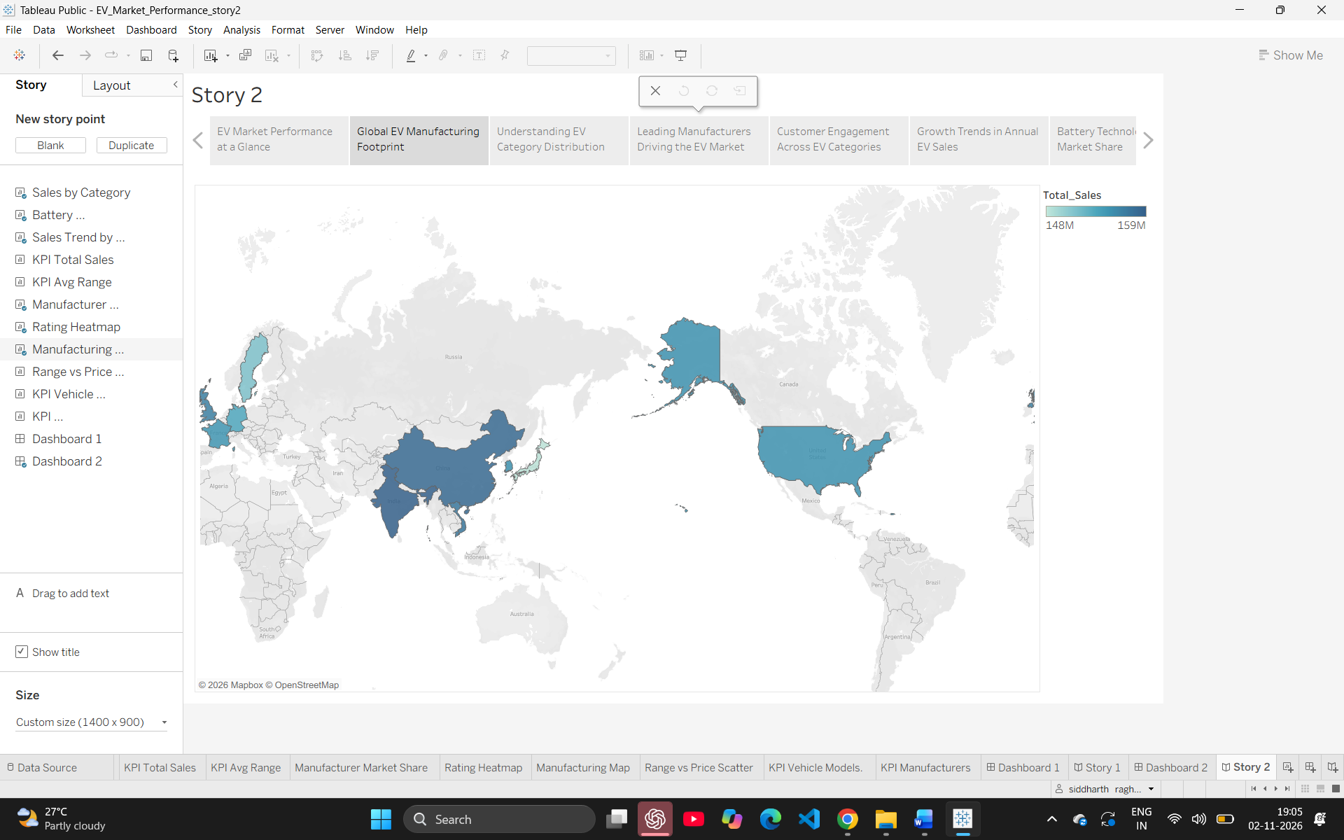
8. ADVANTAGES & DISADVANTAGES
Advantages:
- Highly interactive and visually engaging UI.
- Zero licensing costs by utilizing Tableau Public and open-source Python.
- Centralizes fragmented data into a "single source of truth."
- Responsive design accessible on desktop and mobile.
Disadvantages:
- Requires an active internet connection to load Tableau Public assets.
- Data updates are currently manual (CSV upload) rather than real-time API syncing.
- Data privacy is limited due to the use of the public Tableau server.

9. CONCLUSION
In conclusion, the EV Market Performance & Insights Platform successfully demonstrates how full-stack web development can be combined with Business Intelligence tools. By integrating Python (Flask) with Tableau, the project transformed raw CSV data into an interactive, user-friendly portal. The platform met all functional requirements, achieved a 100% feature implementation rate, and successfully solves the problem of data accessibility for business stakeholders.

10. FUTURE SCOPE
- Cloud Deployment: Host the Flask app on platforms like Render or AWS for public access.
- Automated Pipelines: Integrate live data APIs to replace manual CSV uploads.
- Machine Learning: Deploy predictive ML models (Scikit-learn) to forecast EV market share for 2030.
- Authentication: Add a login portal (Flask-Login) to provide secure, role-based access for different stakeholders.

11. APPENDIX
- Source Code:
  - app.py (Flask backend)
  - templates/index.html (Frontend UI)
  - static/ (CSS, JS, Images)
- Dataset Link: https://www.kaggle.com/datasets/tharishreddy22/electric-vehicle-market-classification-dataset
- GitHub Repository: https://github.com/siddharthh59/EV-Market-Performance-Insights
- Tableau Public Profile: https://public.tableau.com/app/profile/siddharth.raghuwanshi6833/vizzes?showOnboarding=true

